**Motion Equations**

1. v = d / t (CV Only!)

2. vf = vo + at

3. a = (vf – vo)/t

4. d = vot + ½ at2

5. d = ½ (vo + vf)t

6. vf2 = vo2 + 2ad

**Earth’s Gravitational Acceleration: a = - 9.8 m/s2**

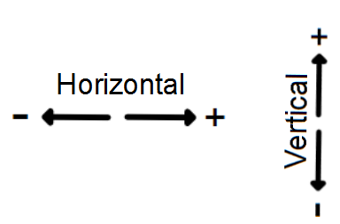

**Motion Equations**

1. v = d / t (CV Only!)

2. vf = vo + at

3. a = (vf – vo)/t

4. d = vot + ½ at2

5. d = ½ (vo + vf)t

6. vf2 = vo2 + 2ad

**Earth’s Gravitational Acceleration: a = - 9.8 m/s2**

